**Md. Robel Ahammed**

**Back-end web developer**

**Address**  : Harashpur, Bijoynagor, Brahmanbaria 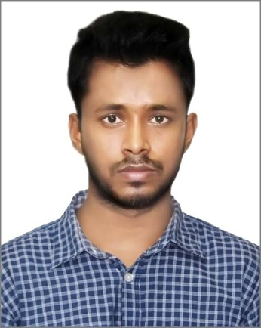

**Phone**  : +8801736-997101

**E-mail** : [mdrobelahmedcse@gmail.com](mailto:mdrobelahmedcse@gmail.com)

**Github**  : [github.com /mdrobelahmedcse](github.com%20/mdrobelahmedcse)

**Linkedin**  : <linkedin.com/mdrobelahmedcse>

**Fiverr :** <fiverr.com/web__programmer>

**Career Objective**

I wish to build up a career in an organization at a challenging position where I will be able to

Improve my knowledge, skills, performance by giving my hard work and passion to raise that

organizations value.

**Education Qualification**

|  |  |  |  |
| --- | --- | --- | --- |
| **Name Of the Examination** | **Board / University** | **Passing year** | **CGPA** |
| B.Sc. Engineering  (CSE) | Stamford University | Running | 3.54 (Out of 4.0) |
| Higher Secondary Certificate (HSC) | Kazi Shofiqul Islam College,Brahmanbaria | 2014 | 4.60 (Out of 5.0) |
| Secondary School Certificate (SSC) | Daud Pur Govt. High School | 2012 | 4.56 (Out of 5.0) |

**Experience**

**Web Developer at Fiverr**

June 2018 to present

-Remote location

My key responsibility is to listen client requirements, make feasible solutions for the problems and design and develop both frontend part and backend part. Frontend part is designed and developed using JavaScript, Jquery, sometimes i used copy design from Google. Backend part is developed with PHP OOP. I’m working on some big ERP and inventory projects here.

**Technical Skills**

|  |  |
| --- | --- |
| **Programming Language** | C, C++, Python |
| **Web Programming Language** | HTML, CSS, Java Script, PHP |
| **Web Framework** | CSS Framework (Bootstrap), PHP Framwork (Laravel), Javascript Framework (Jquery), Ajax |
| **Top Skill** | Back-end web development |
| **Databases** | MySQL |
| **Operating System** | Windows |
| **Text Editor** | Notepad++, Sublime, Atom, PHP Storm |
| **Others Experience** | Microsoft Word, Microsoft PowerPoint, Microsoft Excel |

**Developed Project**

|  |  |  |
| --- | --- | --- |
| **Project Name** | **Made With** | **Link** |
| E-shopper | HTML, CSS, Bootstrap, Java Script, Jquery, Ajax, PHP, Laravel | <https://github.com/mdrobelahmedcse/E-shopper> |
| Blog-System | HTML, CSS, Bootstrap, Java Script, Jquery, PHP, Laravel | <https://github.com/mdrobelahmedcse/Blog-with-Laravel> |
| Restaurant Management | HTML, CSS, Bootstrap, Java Script, PHP, Laravel | <https://github.com/mdrobelahmedcse/Restaurant_management> |
| Shop Management | HTML, CSS, Bootstrap, Java Script, PHP OOP & MySQL | <https://github.com/mdrobelahmedcse/Shop_management> |
| Mailing System | HTML, CSS, Bootstrap, Java Script, PHP OOP & MySQL | <https://github.com/mdrobelahmedcse/Mailing-system> |

**My Strengths**

* Self Motivated and good team player, capable to adapt to changing environments. Good concepts in OOP, Data Structure, Algorithms, SQL.
* Capable to learn any programming language quickly.
* Capable to maintain good communication with co-workers and can complete project in pressure.

**Personal Information**

Full Name : Md. Robel Ahammed

Father’s Name : Md. Nazrul Islam

Mother’s Name : Alladu Begum

Gender : Male

Date of Birth : 18-01-1996

Religion : Islam

Marital Status : Unmarried

Blood Group : ‘AB’ Positive

Nationality : Bangladeshi (by birth)

Permanent Address : Harashpur, Bijoynagor, Brahmanbaria

Present Address : Banglamotor,Ramna,Dhaka

**References**

**Adnan Ferdous Ashrafi**

Senior Lecturer

Dept. of CSE, SUB

Email: <adnan@stamforduniversity.edu.bd>

**Shifat Sharmin Sahpla**

Senior Lecturer

Dept. of CSE, SUB

Email: <shapla203@gmail.com>

I hereby declare that the above statements are correct and complete to the best of my knowledge.

( Md. Robel Ahammed )

****